AWS Task-3
Task Description:

- Create a S3 bucket, with no public access and upload files to the bucket & view the logs using cloudwatch for the uploaded files.
- Launch two ec2-instances and connect it to a application load balancer, where the output traffic from the server must be an load balancer IP address

S3 Bucket Creation:
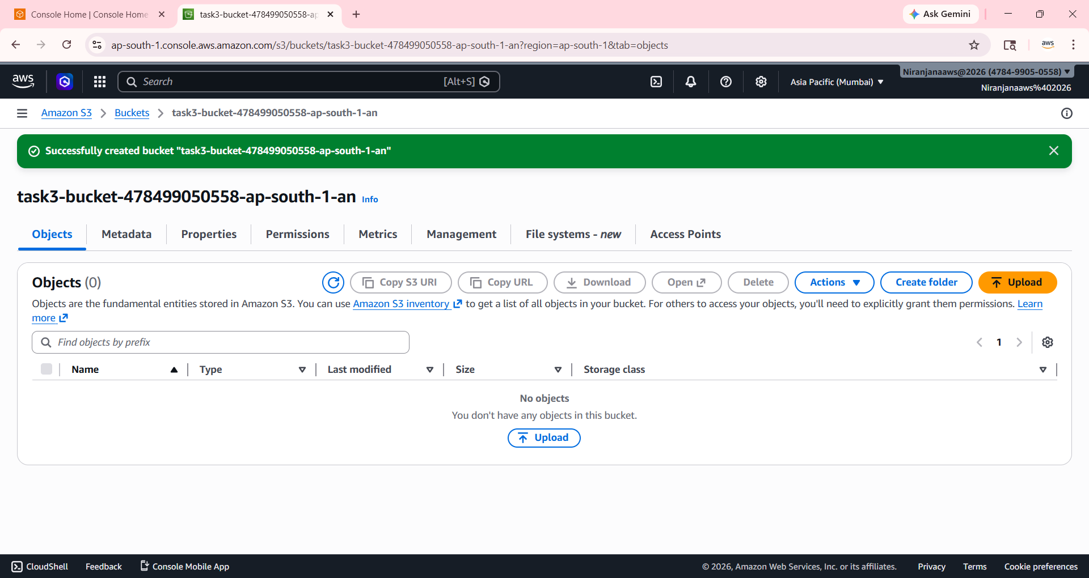
Uploading Files:
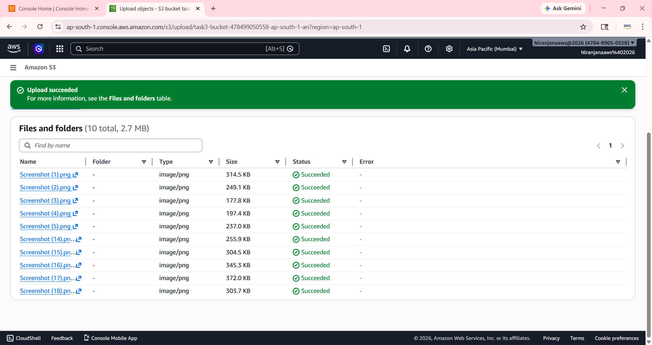
Creating Cloud Trail:
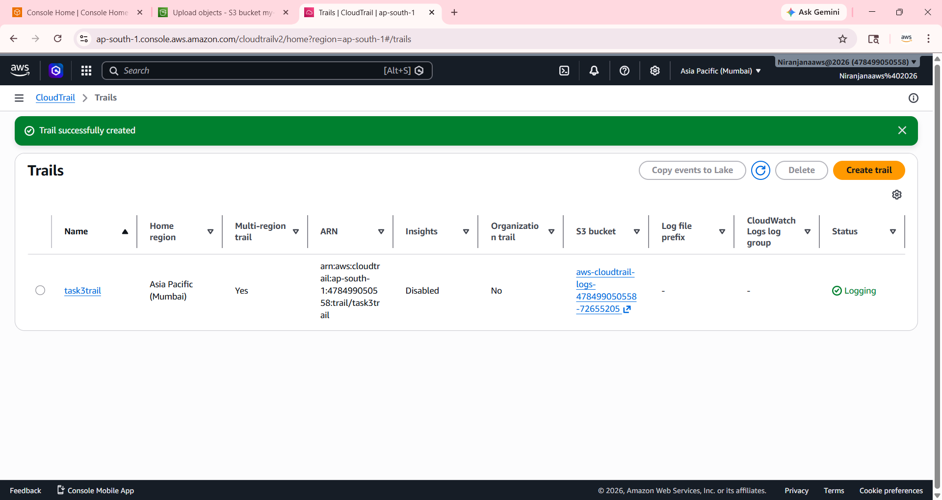
CloudWatch Edit inside CloudTrail:
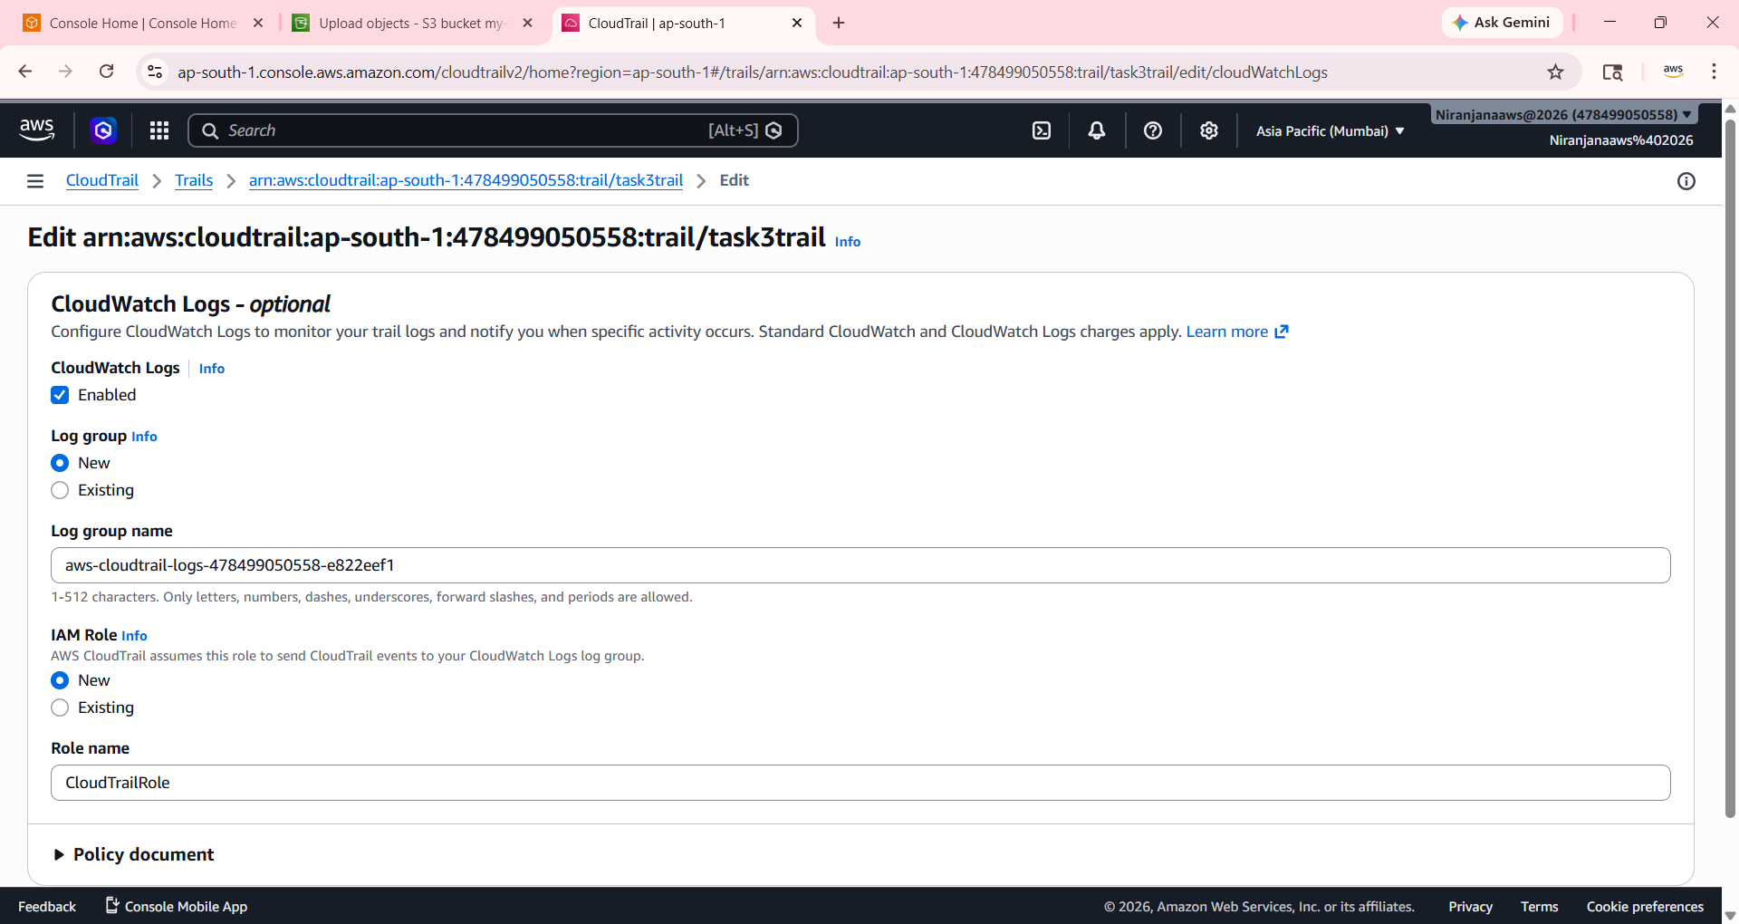

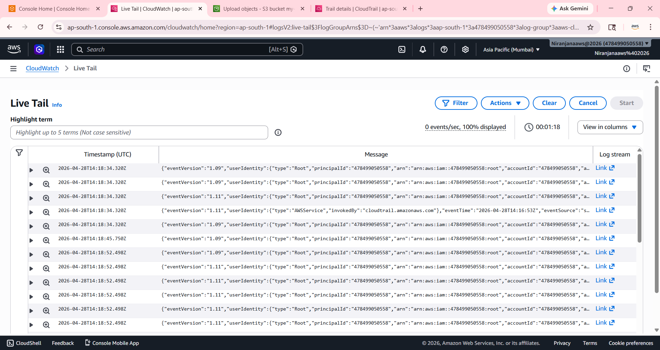

VPC – Created :

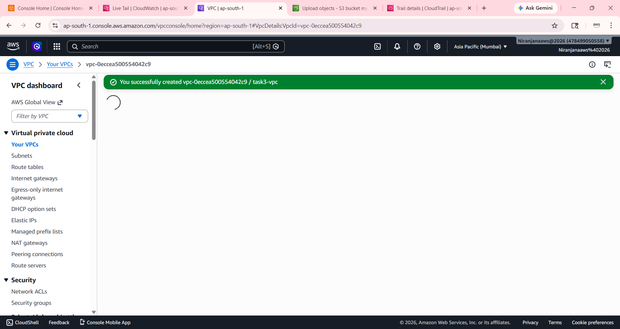

Subnets – Created:
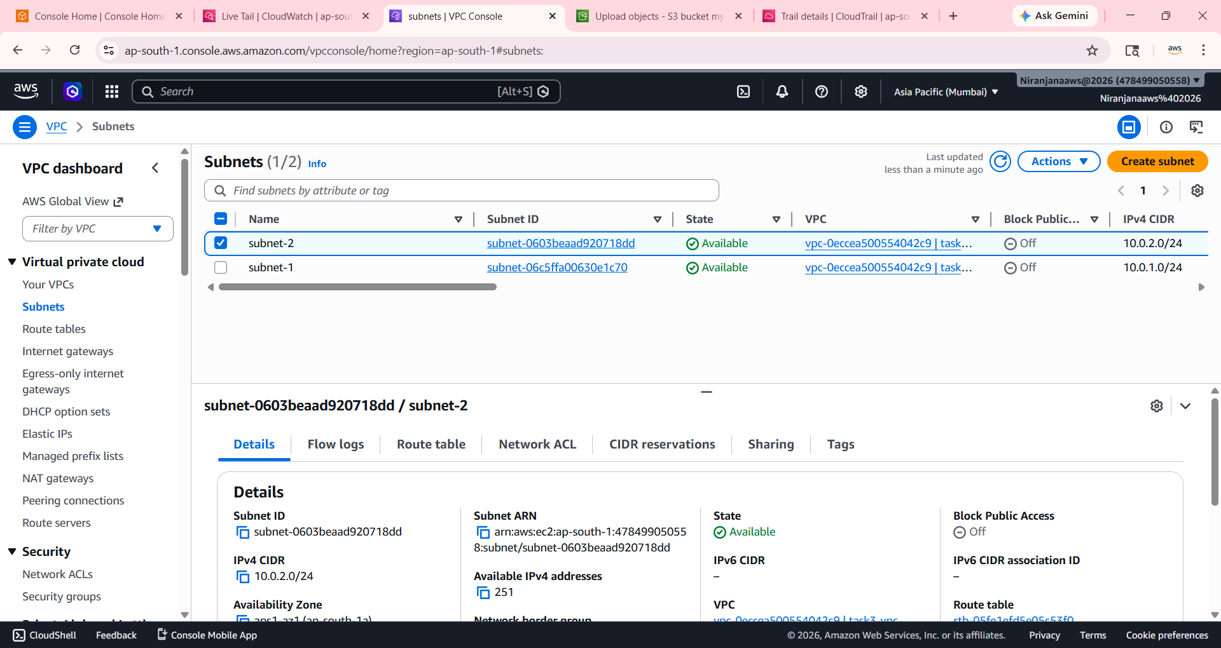
Internet Gateway created – attached to vpc:
